
ST PAUL’S UNIVERSITY
FACULTY OF BUSINESS AND COMMUNICATION
DIPLOMA IN BUSINESS INFORMATION TECHNOLOGY
ONLINE BURSARY MANAGEMENT SYSTEM
CASE STUDY OF NAROK EAST CONSTITUENCY
STUDENT NAME: JANET TUMANKA
REG NO.: DBITNKR/808019
SUPERVISOR: ROSELYN AKINYI
ONLINE BURSARY MANAGEMENT SYSTEM

(A case study of Narok East Constituency)

By

JANET TUMANKA

DECLARATION
Declaration by the student
I declare that this proposal is based on my original work, and has never been presented for the award of diploma in business information technology in St.Pauls University and in any other institution of higher learning
Signature…………………dates………………
JANET TUMANKA
Registration number: DBITNKR808019

Declaration by supervisor
I do hereby certify that this is a true report for the proposal undertaken by the above named student under my supervision and has been submitted to ST.PAULS University upon my approval
Signature……………………………………………………………….date…………………
Mrs. Roselyn Akinyi
Department of INFORMATION TECHNOLOGY

ACKNOWLEDGEMENT
The completion of this research project would have been impossible without the material and moral support from various people. First of all I thank the almighty God for giving me good health, and guiding me through the entire course. I am greatly indebted to Madam Roselyn Akinyi , who was supervisor for her effective supervision, dedication, availability and professional advice. I extend my gratitude to my lecturers who taught me in the Diploma program, therefore enriching my research with the learnt knowledge. Thanks too to the Narok east constituency bursary committee for giving me authority to conduct this research in Narok east constituency. The Narok east member of parliament and the general public who were my respondents deserve my appreciation for their willingness to provide the required information during my research study. My appreciation finally goes to my classmates, with whom I weathered through the storms, giving each other encouragement and for their positive criticism.

DEDICATION

I dedicate this proposal to God, for the wisdom and strength throughout my research, my parents’ and relatives for their continuous support towards my academic achievement.

ABSTRACT
Online bursary management system is a computerized system that will enable online application of bursary funds. The system will be developed for Narok east constituency. Constituency Development Fund (CDF) in Kenya has been hailed as one of the most innovative creations of the National Alliance Rainbow Coalition (NARC) administration (2003-2007) (Gaitho, 2005). With the Government working hard to cultivate an image of transparency and inclusiveness for good governance in Kenya, implementation of E-Governance services for creating better relations between citizens and those in power has been a real struggle. ICT has been exploited in this relationship to help transform the accessibility, quality and cost-effectiveness of public services. However, in Narok east constituency there have been notable challenges in the CDF Bursary Fund application process including but not limited to, costly and time consuming trips, difficulty in accessing and acquiring information, delayed information relay about commencement of application window and updates on disbursements, as well as lack of student historical data with regards being a bursary beneficiary. In order to establish the relevant system that will meet the requirements needed, data collection methodologies including interviews with stakeholders, questionnaires with CDF Bursary applicants will be used to highlight the needs of the applicants. Upon the realization of this system, quick access to information was attained. It also enabled applicants to make applications anywhere without necessarily travelling to the constituency offices, in addition the system will have capacity toward minimizing delay within the CDF offices thus enabling timely disbursements while also providing feedback through text messages informing applicants of their bursary status. The system modules will include Applications module; User management module; Disbursements module and Notification module. The online system will make great use of the internet technology with database, which will capture, organize and store records of applicants. The user graphical interface will be designed using PHP and HTML. The scripting languages of Css and java script will also be used; My SQL will be used to create the database. The designing tools to be used may include the DFD, Use Case diagram, the access to the system will be permitted through use of a password. In conclusion this system will solve a number of problems faced by Narok east constituency bursary committee.

LIST OF ABBREVIATIONS

CBF: Constituency Bursary Fund
CBFC: Constituency Bursary Fund Committee
CDF: Constituency Development Fund
CSS: Cascading Style Sheets
DFD: Data Flow Diagrams
ERD: Entity Relation Diagrams
HTML: Hypertext Mark-up Language
NARC-National Rainbow Coalition
NEC: Narok East Constituency
PC: Personal Computer
PHP: Hypertext Pre-processor

Contents
Declaration………………………………………………………………………………………………………………………………..3
Acknowledgment………………………………………………………………………………………………………………………4
Dedication…………………………………………………………………………………………………………………………………5
Abstract………………………………………………………………………………………………………………………….…………5
Chapter 1…………………………………………………………………………………………………………………………………..8
Introduction……………………………………………………………………………………………………………………………….8
Background………………………………………………………………………………………………………………………………….8
Problem statement………………………………………………………………………………………………………………………9
Problem solution…………………………………………………………………………………………………………………………..9
Objective……………………………………………………………………………………………………………………………………..10
Main objectives……………………………………………………………………………………………………………………………10
Specific objectives………………………………………………………………………………………………………………………..10
Research questions……………………………………………………………………………………………………………………….10
The scope………………………………………………………………………………………………………………………………………10
Justification……………………………………………………………………………………………………………………………………11
chapter 2………………………………………………………………………………………………………………………………………..12
Literature review…………………………………………………………………………………………………………………………….12
Introduction to literature review……………………………………………………………………………………………..…..…12
Online application system…………………………………………………………………………………………………………..…..12
Online disbursement system…………………………………………………………………………………………………………..13
SMS notification system…………………………………………………………………………………………………………………..14
Database management system…………………………………………………………………………………………………..……16
Research gap……………………………………………………………………………………………………………………………….…..16
Conclusion……………………………………………………………………………………………………………………………………….16
Chapter 3…………………………………………………………………………………………………………………………………………17
Methodology………………………………………………………………………………………………………………………………….17
Introduction…………………………………………………………………………………………………………………………………..17
Data collection instrument………………………………………………………………………………………………………17
Data collection process…………………………………………………………………………………………………………..18
Interview…………………………………………………………………………………………………………………………………18
Observation…………………………………………………………………………………………………………………………….18
Questionnaire…………………………………………………………………………………………………………………………19
System requirement………………………………………………………………………………………………………………19
Functional requirement…………………………………………………………………………………………………………19

CHAPTER ONE

INTRODUCTION

1.1 Background of the Study
A system is a group of elements or components joined together to fulfil a certain function. Management information system (Gupta, 2012)
Management system: A management system is defined as an assemblage of facilities and personnel for collecting, processing, storing and retrieving of information required by managers in the performance of their functions (Saleemi, April, 2011)
The Narok east constituency is an electoral constituency in Kenya within the larger Narok County. It was established in the 2013 election, the constituency population is estimated at 82956 and an area square of 2059.59km square. (Wahome, 2014) The Narok east constituency bursary committee is consisted of 16 members, while forming the committee the 1/3 gender rule is observed. Among the committee are representatives of the disabled and the youth.
In Narok east constituency, the process of bursary applications is fuzzy. All one needs is voter’s registration, identification card and legal stamps from the constituency administration. Following a recent observation made on one of my visit, the committee in charge of bursary issues the application forms to applicants’ who upon filling it, return it to the office for official evaluation. The application process is long, tedious and sometimes complicated follows a long procedure of traveling long journeys to obtain the forms in the constituency. If the participants or signatories required live far apart, one has to make trips which might incur a considerable cost in both time and money resources. Often, the traveling meets challenges such as delay at the CDF offices, deadline for receiving the applications has already passed or the forms have all been issued out. After disbursement of the funds, one has to keep calling the CDF officials or physically walk to the CDF premises to be updated on the progress of the application and when disbursements shall be made. In some cases, officials may be rude and unwilling to tackle such kinds of queries a situation that users have to put up with every time they make an application. In addition, the CDF officials do not maintain historical data for the student beneficiaries to gauge the impact of the funds

1.2 Problem Statement
Access to information about CDF Bursary Fund application is not easy. Additionally, the actual application process is long, tedious and sometimes complicated as applicants have to travel a long way to pick the application forms which are only found in CDF offices. Slow bursary application and verification process lead to delay in CDF offices which is the ultimate course of untimely disbursement. After application of the funds, breakdown of communication between applicants and the officials occurs. One has to keep calling the CDF officials or physically walk to the CDF premises to be updated on the progress of the application and when disbursements shall be made. In some cases, officials may be rude and unwilling to tackle such kinds of queries a situation that users have to put up with every time they make an application. In addition, the CDF officials do not maintain historical data for the student beneficiaries to gauge the impact of the funds

1.3 Problem Solution
The recommendations to make the bursary scheme more effective and efficient are as follows;
The system will enable the applicants to apply for the bursary fund anywhere without making unnecessary costly, tedious and time-consuming trips to the constituency premises. This system will provide quick access to information will be developed and will provide up to date information about the availability of bursary funds and eligibility policies.
The established system will reduce delay in the CDF offices which is the ultimate cause to untimely disbursements. This can certainly be achieved by allowing the system to carryout verifications and make allocations quickly. In the proposed system upon successful applications the applicants will receive notification about disbursements. The system will use rich information technology tools to develop a centralized database to enable the CDF officials to maintain historical data for the student beneficiaries to gauge the impact of the funds.

1.4.0 Objectives

1.4.1 Main Objective
The primary objective of this research is to come up with an online system that will help the students apply for the bursary anywhere without making trips to various offices within the constituency in such of funds.

1.4.2 Specific Objectives
- To develop an online application system that is cost effective and minimizes unnecessary inconveniences and time taken while seeking and applying for bursary funds as applications will be made possible anywhere.
- To develop a system that will enable the bursary applicants to make registration and get quick access to readily available and reliable information.
- To develop a system that will provide notification to all successful applicants notifying them of application status.
- To create a centralized database system that will be useful to the CDF officials in maintaining ad retrieving beneficiaries’ historical data which will be used to gauge the impact of the funds?
1.5 Research Questions
- Will the system be able to allow applicants apply for bursary from anywhere?
- How will the system provide applicants with quick first-hand information?
- Will the system be in a position to send notifications to the applicants on their bursary disbursement?
- Will the system be able to store and retrieve historical data of all the beneficiaries?

1.6 The Scope
This project will be designed for Narok east constituency but can be used by other constituencies that would want to enhance their bursary disbursements and records processes. The system will have the following modules:
Applications module; module used by CDF beneficiaries who want to initiate the process of applying for the bursary fund.
Admin Module; module used by the CDF officials to manage the users in the system
Disbursements Module; module used to monitor the disbursement made to the beneficiaries. Reports from this module are a good source of information for non CDF stakeholders who want to keep track of how the funds are utilized.
Notification module: will provide updates to the applicants on the availability of funds and notify them of their previous allocations and disbursements and their current bursary application.

1.7 Justifications
The system will help the bursary applicants to make quick applications wherever they are just by login to the system thus minimizing time ad monetary cost committed while traveling from one office to another thus minimizing delay. The system will provide ample storage, retrieval of data in a centralized database. In conclusion the system will provide notifications to applicants on their bursary status.

CHAPTER TWO

LITERATURE REVIEW

2.1. Introduction to Literature Review
This chapter will dive into the history, the impact and the efficiency of Constituency Development Fund (CDF). The Constituencies Development Fund (CDF) was created by the Constituencies Development Fund Act, 2003. Its aim was to address poverty at grassroots level by dedicating a minimum of 2.5% of the Government ordinary revenue to grassroots development and the reduction of poverty. The fund is managed by the Constituencies Development Fund Board (CDFB). CDF Act 2003 has been replaced with CDF Act 2013 that is more aligned to the constitution of Kenya 2010 CDF (2013)
2.2 Online Application System
The web application was built using Code-Igniter content management systems (CMS) written in PHP5. The website is hosted on an online Apache HTTP server. The web application for which CDF officials interact with the system entailed the functionalities such as; capabilities to capture new users in the system as well as view already registered members, upload new information, and allocation of disbursements for qualified candidates and extraction of required reports.
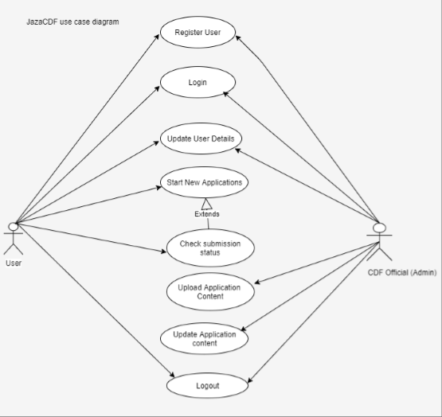

2.3 Online Disbursement System
The purpose of the disbursement system is to provide guidelines that ensure cash is disbursed only upon proper authorization and that the request for payment is supported by the appropriate documentation, for valid business purposes, and properly recorded. Source (Point, 2017) 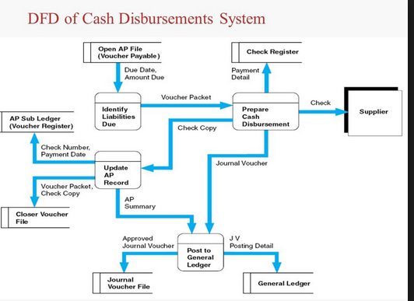

2.4 SMS Notification System
SMS stands for short messaging service, a protocol used for sending short messages over wireless network. Notification is a combination of software and hardware that provides a means of delivering a message to a set of recipients (wiseGEEK., 2016). It commonly shows activity related to an account. Such systems constitute an important aspect of modern Web applications. The first notification SMS message was sent over the Vodafone GSM network in the United Kingdom on 3 December 1992, from Neil Papworth of Sema Group (now Mavenir Systems) using a personal computer to Richard Jarvis of Vodafone using an Orbitel 901 handset. The text of the message was "Merry Christmas." In this context the students will be alerted of their bursary allocations and disbursements. 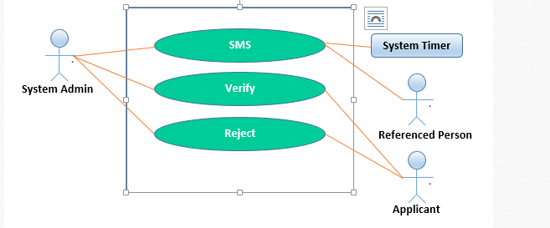

2.5 Database Management System
A database-management system (DBMS) is a computer-software application that interacts with end-users, other applications, and the database itself to capture and analyze data. A general-purpose DBMS allows the definition, creation, querying, update, and administration of databases. (Codd)
Table 2.5.1shows the Members table that is used for recording the applicants who have registered in the Jaza CDF application. The table has the memberID as a primary key.
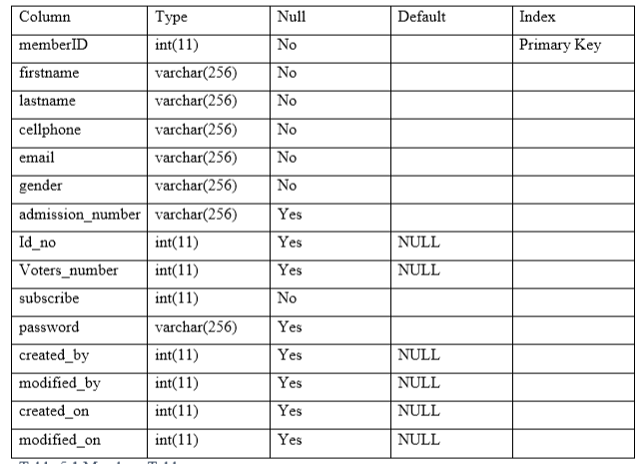
Source jaza cdf

2.5 Research Gap
Most researchers based their research on android mobile application which was not compatible to all browsers. My research will be based on a full system which is compatible to nearly every browser this will take care of high school students who do not own android phones but have access computers

2.6 Conclusion
Drawing conclusion from the above studies, it is evident an online bursary process will simplify the tedious process; minimize both time and monetary cost. If embraced well could lead to more effectiveness of the bursary funds.

CHAPTER THREE
Methodology
methodology is the systematic, theoretical analysis of the methods applied to the field of study. It comprises the theoretical analysis of the body of methods and principles associated with a branch of knowledge typically it comprises of concept such as paradigm, theoretical model, phases and qualitative and quantitative techniques.
3.1 Introduction
This chapter discusses the research methodology used in this study and provides a general framework for this research. The chapter presents details of the research design, target population, sample and sampling procedures, description of research instruments, validity and reliability of instruments, data collection procedures, data analysis techniques and ethical considerations while conducting the study.
3.2 Research Design
A research design is described as a plan, structure and strategy of investigation to obtain answers to research questions and control variance. Additionally, a study design is the plan of action the researcher adopts for answering the research questions and it sets up the framework for study or is the blueprint. This study will adopt a survey research design. This design is a method of collecting information by interviewing or administering a questionnaire to a sample of individuals. The main feature of survey research design is to describe specific characteristics of a large group of persons, objects or institutions, through questionnaires. Besides, the design will be used because of its descriptive nature in order to assist the researcher in collecting data from members of the sample for the purpose of estimating the population parameters.

Data Collection Instruments
The main data collection instruments that will be used in this study include the questionnaire. This will be used for the purpose of collecting primary quantitative data. Additionally, the questionnaires will be used for the following reasons:
a) Its potentials in reaching out to a large number of respondents within a short time,
b) Able to give the respondents adequate time to respond to the items,
c) Offers a sense of security (confidentiality) to the respondent and
d) It is objective method since no bias resulting from the personal characteristics (as in an interview).The questionnaire is divided into the main areas of investigation except the first part which captures the demographic characteristics of the respondents. Other sections are organized according to the major research objectives.

Data Collection Process
Prior to the commencement of data collection, the researcher will obtain all the necessary documents, including an introduction letter from the University. Audience with the sampled local authorities in the region will also be sought to clarify the purpose of the study. Upon getting clearance, the researcher in person will distribute the questionnaires to the sampled individuals who are living in the informal settlements.
Assistance from the local authorities will be sought. Use of questionnaires is expected to
ease the process of data collection as all the selected respondents will be reached in time. During the distribution of the instruments, the purpose of the research will be explained.
4.0 interviews
Interviews can be defined as a qualitative research technique which involves conducting intensive
individual interviews with a small number of respondents to explore their perspectives on a particular
idea, program or situation.
There are three different formats of interviews: structured, semi-structured and unstructured.
4.2Observation
Observation, as the name implies, is a way of collecting data through observing. Observation data
collection method is classified as a participatory study, because the researcher has to immerse herself in the setting where her respondents are, while taking notes and/or recording. Observation as a data collection method can be structured or unstructured. In structured or systematic observation, data collection is conducted using specific variables and according to a predefined schedule. Unstructured observation, on the other hand, is conducted in an open and free manner in a sense that there would be no predetermined variables or objectives. Advantages of observation data collection method include direct access to research phenomena, high levels of flexibility in terms of application and generating a permanent record of phenomena to be referred to later. At the same time, observation method is disadvantaged with longer time requirements, high levels of observer bias, and impact of observer on primary data, in a way that presence of observer may influence the behaviour of sample group elements.
4.3 questionnaires
Questionnaires can be classified as both, qualitative and quantitative method depending on the nature of questions. Specifically, answers obtained through closed-ended questions with multiple choice answer options are analysed using quantitative methods and they may involve pie-charts, bar-charts and percentages. Answers obtained to open-ended questionnaire questions are analysed using qualitative methods and they involve discussions and critical analyses without use of numbers and calculations.
4.6 system requirements
system requirements or software requirements are a listing of what software programs or hardware
devices are required to operate the program or game properly

Operating System (i.e. Windows XP, SP2 )
1. Processor Speed (i.e. Pentium 4, 3.2 GHz or Power PC G5, 2.0 GHz)
2. Memory, a.k.a. RAM (i.e. 512 MB)
3. Graphics Card (i.e. ATI Radeon 9800 w/ 256 MB video memory)
4. Hard Disk Space (i.e. 80 GB available)
5. I/O Ports (i.e. USB, Fire wire, Serial, Parallel, SCSI, VGA, DVI ports)
4.6.1 Functional requirements
A functional requirement, in software and systems engineering, is a declaration of the intended
function of a system and its components. Based on functional requirements, and determines the
behaviour (output) that a device or software is expected to exhibit in the case of a certain input.
4.6.2 Non-functional requirements
Any requirement which specifies how the system performs a certain function. In other words, a non-functional requirement will describe how a system should behave and what limits there are on its functionality. Example of functional requirements is performance for time, throughput, utilization, static volumetric, scalability and capacity.
SDLC Model: Waterfall model
SDLC Model: Waterfall model
Requirements
System design
implementation
testing
deployment
maintenance

Reasons for waterfall model
1.The definition of product is stable
2.The terminology is understood
3.There are ambiguous reguirements
4.The requirements are well known, clear and fixed

Advantages of waterfall model
1.Simple and easy to understand and use
2.Works well for smaller projects where requirements are well understood
3.Phases are processed and completed at a time
4.Easy to manage due to the rigidity of the model
Disadvantages of waterfall model
1.High amount of risk and uncertainty
2.Not good for complex and object oriented projects
3.It does not allow for much reflection or revision
4.No working software is produced until late during the lifecycle
flow chat model

Flowchart model
start
Member?
Enter
details
end
Make payments
Reg succesfully
order
confermation

Dataflow diagram
Submit user details

User
1
Register user
D1
User
details
Store user Confirm details
Details

Retrieve user details
2
Make new application

Verify user details start new application
Retrieve user details

Check application status
3
Check new status

CDF official

Submission response
Query submission status

Submit application information
4
Update application
Information
Delete information
D2
App data

Update information
Send notification Receive notification
5
Notification

Entity relationship diagram
name
address
ID no
amount
Payment is done
get access
Booking already done
Booking now
Booking
details
Booking is done and booking card is given
Show booking card
applicant

Physical Design
This design translates the abstract logical model into specific technical design for the new system.
Use case diagram

Register

Login

Update User Details

User
Start New Application
cdf official

CDF
Upload Application Content
exted
official
Check Submission Status

Send notification
View notifications

Logout

Refferences
(Gaitho, 2005).
(Gupta, 2012)
(Saleemi, April, 2011)
(Wahome, 2014)
(wiseGEEK., 2016)
(Codd)
(Spence, 2004)

3.4.5 Dummy of the proposed system

Login page
Online Bursary Management System
User Name

Password

Register
Login

Applicant Details

Name

Phone

Id number

Amount paid

Activity Schedule

No. | Activity | Duration | Start Date | End date
1. | Planning | 1 week | 23/8/2019 | 30/8/2019
2. | Requirement analysis | 1 week | 2/9/2019 | 12/9/2019
3. | Introduction | 1 weeks | 16/9/2019 | 30/9/2019
4. | Problem statement | 1 week | 2/10/2019 | 12/10/2019
5. | Literature review | 1 weeks | 18/10/2019 | 25/10/2019
6. | Methodology | 2 weeks | 29/10/2019 | 05/11/2019
7. | Presentation | 1 day |  | 29/11/2019

